Maarten Goossens

Universidad de los Andes, Colombia

**Costa, Lucio (1902-1998)**

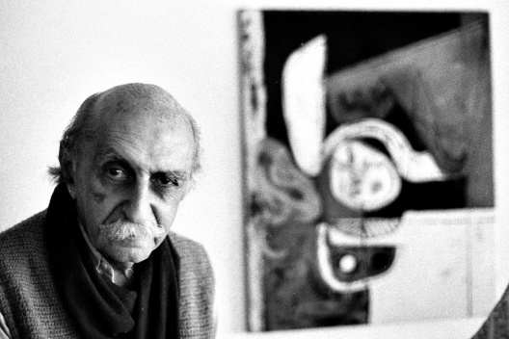

Lucio Costa. Photo by Hugo Segawa.

<http://www.vitruvius.com.br/revistas/read/arquitextos/11.125/3629>

Brazilian architect Lucio Marçal Ferreira Ribeiro Lima Costa was a founding father and one the main exponents of Brazilian modern architecture. After passing his childhood in Europe, Costa enrolled in the National School of Beaux-Artsin Rio de Janeiro. Although his first years as a practicing architect were characterized by the influence of the neo-colonial movement then in vigour, by 1929 Lucio Costa became, along with Gregori Warchavchik, one of the first advocates of modern architecture in Brazil, influenced by the ideas of Le Corbusier, who had visited Brazil in 1929. Costa was given the opportunity to actively promote modern ideas when he was appointed, in 1930, as head of the National School of Beaux-Arts.

One of Costa’s most significant designs from this period, and a landmark in Brazilian and Latin American modernism, is the Ministry of Education and Public Health (1936-1945), designed with Affonso Eduardo Reidy, Oscar Niemeyer –a former student of Costa’s-, and with the participation of Le Corbusier as a design consultant, among others. During his career, Costa was able to combine architectural design, landscape architecture, town planning, public service, heritage protection and writing. His most relevant work is the layout of Brasilia, the newly built capital city of Brazil (1956-1960).

Brasilia, the endeavor of President Juscelino Kubitschek to establish a new capital city far from Salvador and Rio de Janeiro as a symbol of the renovated nation, was a mega-project not surpassed in scale since then. Costa won a competition with a scheme that organizes the city along two crossing axes. One of the axes was later given a slightly bending shape, leaving the outline of the city to resemble the bird or an airplane Brasilia is famously associated with. Along one axis the public buildings, most of them to be designed by Niemeyer, were situated, while the other axis connected a series of *superquadras,* neighborhood units with high-rise dwellings and a small number of low-rise buildings in which basic facilities were to be housed.

Costa explained that his design should be understood in terms of different scales, or environments: the monumental (the central axis with the government buildings, bus terminal, cathedral), the gregarious (an area left open to fulfill other central functions in the future, such as commerce, possibly with a higher density than the rest of the city), the residential (the *superquadras*) and the pastoral (the large green spaces left open between environments, neighborhood units and transit infrastructure. Notwithstanding criticism –mostly referring to the sharp social contrasts between Costa’s city and the surrounding slums or to the excess of empty space- Brasilia is a modern utopia turned reality and as such it is a UNESCO World Heritage Site since 1987.

**List of works**

1936-1945 Ministry of Education and Public Health, Rio de Janeiro, 1936-1945. With Affonso Eduardo Reidy, Carlos Leão, Jorge Moreira, Oscar Niemeyer, Ernani Vasconcellos, Le Corbusier.

1938-1939 Brazilian Pavillion at the World Fair, New York, USA. With Oscar Niemeyer.

1956-1960 Brasilia, urban plan.

**References and further reading**

Nobre, Ana Luiza, c.s. (eds.), *Un modo de ser moderno. Lucio Costa e a crítica contemporânea.* São Paulo: Cosac & Naify, 2004.

Segawa, Hugo. *Architecture of Brazil 1900-1990.* New York: Springer, 2013.

**Visual material**

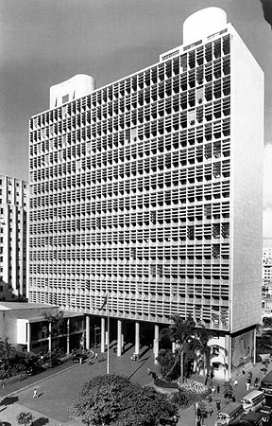

Lucio Costa and others. Ministry of Education and Public Health. Rio de Janeiro, Brazil, 1936-1945.

<http://thaa2.files.wordpress.com/2009/08/003452001013.jpg>

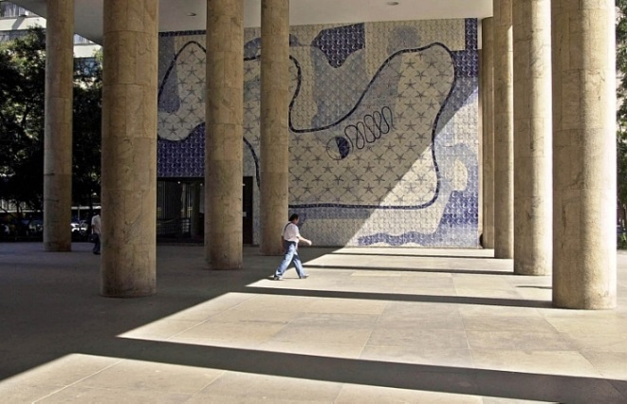

Lucio Costa and others. Ministry of Education and Public Health. Rio de Janeiro, Brazil, 1936-1945.

<http://topicos.estadao.com.br/fotos-sobre-oscar-niemeyer/conheca-as-obras-mais-importantes-da-carreira-de-oscar-niemeyer,2F068DE2-57D7-4AAD-9200-A36A3C4FE5DF>

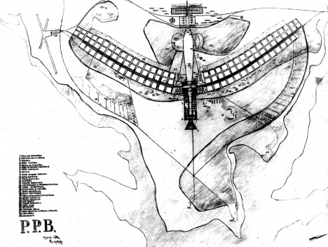

Lucio Costa. Pilot Plan of Brasilia.

<http://www.vitruvius.com.br/revistas/read/arquitextos/11.125/3629>

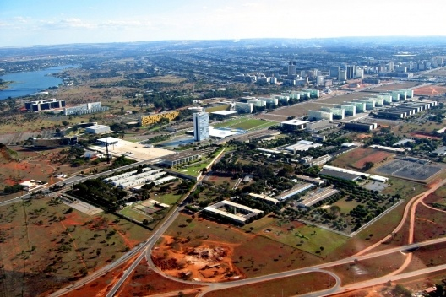

Monumental axis of Brasilia. Town planning by Lucio Costa, government buildings designed by Oscar Niemeyer.

<http://www.vitruvius.com.br/revistas/read/arquitextos/11.125/3629>